PHYS1401 Midterm#2 (105/100 pts)
NOTE(IMPORTANT!!): Please detach, sign, and submit the equation sheet to receive credit.
Print Name:__________________________________________________________________________
Student ID:________________________ Course Section:_____________________________________
Part I: Multiple-choice Questions (Only the answer shall be credited. Each question has only one correct answer.)
- (5pts) Consider an object doing a uniform circular motion. Which of the following statements is correct?
- The acceleration of the object is zero since the speed is constant.
- The acceleration of the object is non-zero since the velocity direction changes.
- The acceleration changes the magnitude of the velocity.
- None of the above is correct.

- (5pts) A 1500 kg fridge is at rest on a horizontal kitchen floor with a coefficient of static friction µ_{s} = 0.44 and a coefficient of kinetic friction µ_{k} = 0.35. A horizontal force of 5500 N is applied to the fridge. What is the magnitude of the frictional force?
- 6500 N.
- 5500 N.
- 5100 N.
- 15000 N.

- (5pts) A 74 kg person is standing on a scale in an elevator that is moving upward at a constant velocity of 1.3 m/s. What is the person's apparent weight?
- 0 N
- 820 N.
- 630 N.
- 730 N.

- Given an airplane’s velocity relative to the wind as ${\vec{V}}_{aw}$, the wind’s velocity relative to the ground as ${\vec{V}}_{wg}$, and the airplane’s velocity relative to the ground as ${\vec{V}}_{ag}$, identify the correct vector tip-to-tail triangle representing the relationships between ${\vec{V}}_{aw}$, ${\vec{V}}_{wg}$and ${\vec{V}}_{ag}$.
A | 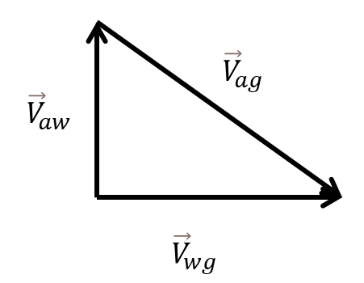 | B | 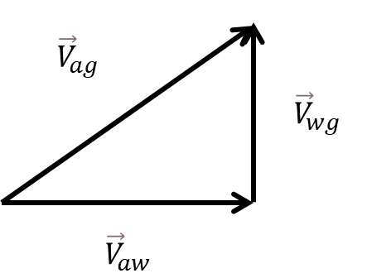
C | 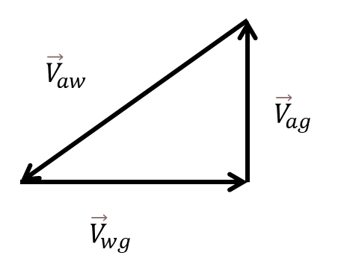 | D | 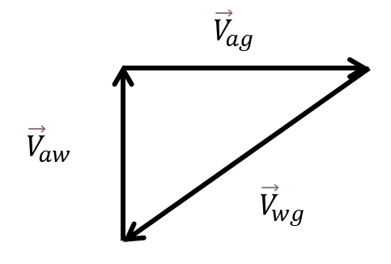

- (5pts) A ball (mass 0.40 kg) is initially moving to the left at 20 m/s. After hitting the wall, the ball moves to the right at 20 m/s. Which of the following statements is correct?
- The momentum of the ball does not change during the collision with the wall.
- The kinetic energy of the ball does not change during the collision with the wall.
- The impulse of the net force on the ball during the collision is 16 kg∙m/s to the left.
- The impulse of the net force on the ball during the collision is 0 kg⋅m/s.

- (5pts) The electric force is given by the equation ${\vec{F}}_{e,12}=k\frac{q_{1}q_{2}}{r_{12}^{2}}{\hat{r}}_{12}$ and the universal gravitational force is given by the equation ${\vec{F}}_{g,12}=-G\frac{m_{1}m_{2}}{r_{12}^{2}}{\hat{r}}_{12}$ According to your understanding of these two equations, which of the following statements is correct?
- The direction of ${\vec{F}}_{g,12}$ is opposite to the direction of ${\hat{r}}_{12}$.
- The direction of ${\vec{F}}_{g,12}$ is always the same as the direction of ${\hat{r}}_{12}$
- The direction of ${\vec{F}}_{e,12}$ is opposite to the direction of ${\hat{r}}_{12}$.
- The direction of ${\vec{F}}_{e,12}$ is always the same as the direction of ${\hat{r}}_{12}$

- (5pts) A passenger is standing on a scale in an elevator. The scale sits on the floor of the elevator. The elevator now begins to descend. Starting from rest, it takes the elevator 6 seconds to get up to its downward speed of 12 m/s. Which of the following statements is correct?
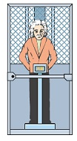
- There are two forces exerted on the passenger: the gravitational force and the normal force from the scale.
- The net force acting on the passenger is zero.
- There are three forces exerted on the passenger: the gravitational force, the normal force from the scale and the normal force from the elevator.
- The acceleration of the passenger is 9.8 m/s².

- (5pts) Two boxes are stacked as shown below. According to Newton’s third law, which of the following is a correct pair of action-reaction (Newton’s Third Law) forces?
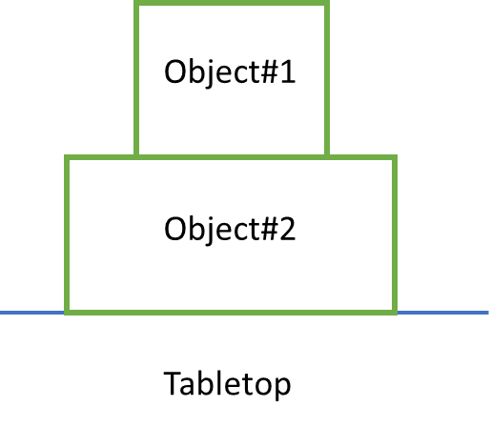
- The normal force exerted by object #2 on object #1 and the gravitational force on object #1.
- The gravitational force on object #1 and the downward force that object #1 exerts on object #2.
- The normal force exerted by object #2 on object #1 and the gravitational force on object #2.
- The normal force exerted by object #2 on object #1 and the downward force that object #1 exerts on object #2.
- (5pts) What is the average force of the impulse in the following F-t plot?
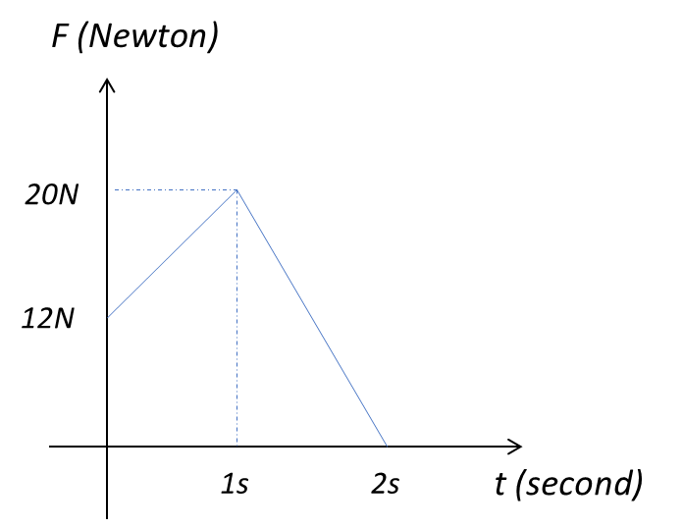
- 12N
- 20N
- 16N
- 13N

- (5pts) A baseball m = 0.59 kg is spun vertically on a massless string. The baseball is passing the bottom of the circle with a tension T = 8.7 N along the string. What is the instantaneous acceleration at this moment?
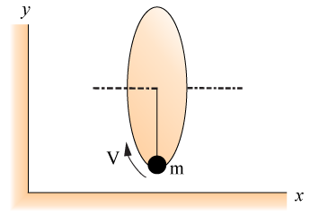
- The magnitude of the acceleration is 4.9 m/s² and its direction is vertically downward.
- The magnitude of the acceleration is 9.8 m/s² and its direction is vertically downward.
- The magnitude of the acceleration is 4.9 m/s² and its direction is vertically upward.
- The magnitude of the acceleration is 6.3 m/s² and its direction is vertically upward.

Part II: Problem-solving Question (Please present the complete problem-solving procedure. Answers with no supportive calculation shall not be credited)
- (25pts) A small box with mass 270 g slides down a ramp with initial velocity $0m/s$ as shown below. The ramp makes an angle $75°$ with the vertical direction and the coefficient of kinetic friction between the box and the ramp is $0.15$. If the length down the ramp is a distance 1.8 m, what is the magnitude of the velocity when the box reaches the end of the ramp?

  - (5pts) Please draw the free-body diagram for the box with a proper coordinate system.

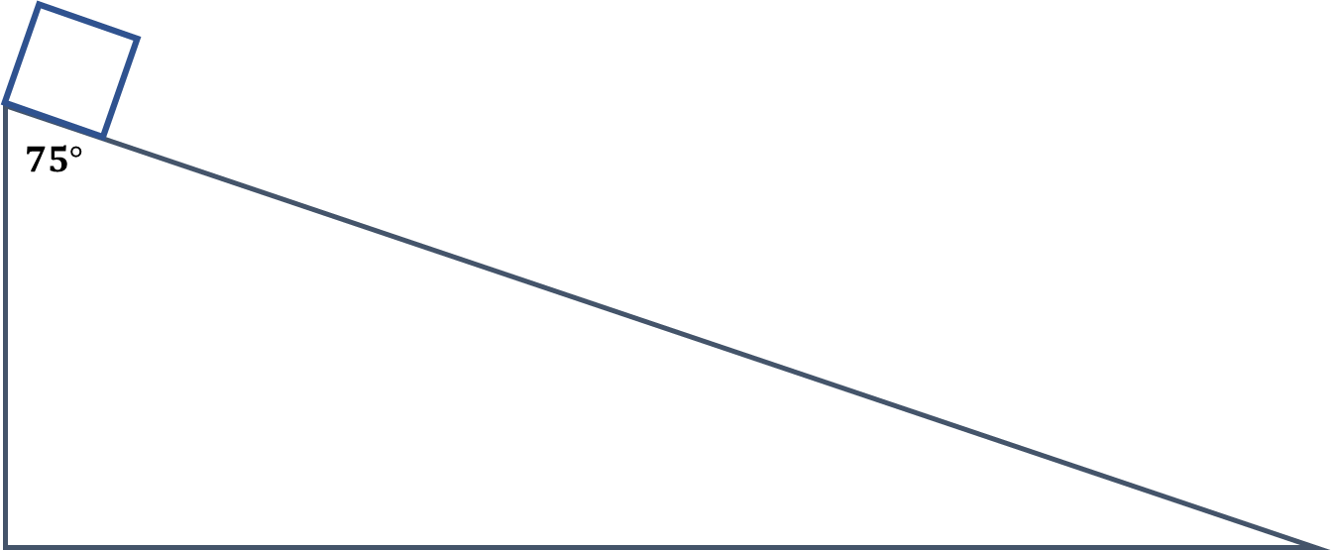

  - (20pts) This problem can be solved using kinematics, the work-energy theorem, or the principle of energy conservation. Choose any two of these three methods to solve the problem and verify that both approaches yield the same result.

- (15pts) Train cars are coupled by colliding with each other. Suppose two loaded train cars are moving toward one another on a horizontal track: the first car has a mass of 205,000 kg and is traveling at 0.275 m/s to the right, while the second car has a mass of 52,500 kg and is moving at 0.105 m/s to the left. What are the magnitude and direction of their final velocity (in meters per second) after the collision? Using the five-step problem-solving approach, solve the problem.

- (15pts) A ball of mass m is thrown vertically upward and reaches a maximum height h. Take the zero of gravitational potential energy to be at ground level. Assume air resistance is negligible. Using the given variables (g, m, h), write expressions for the following questions. Note: Not all variables may be needed.
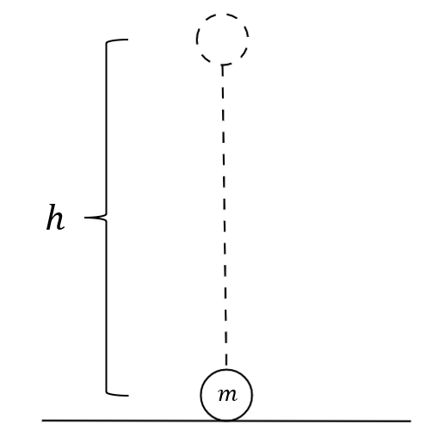
  - (5pts) Derive an expression for the ball’s initial speed.

  - (5pts) Derive an expression for the work done by the gravitational force as the ball moves from the ground to its maximum height.

  - (5pts) Derive an expression for the change in gravitational potential energy as the ball drops from the maximum height to a height of h/2.

Equation Sheet
Gravitational constant: g = 9.8 m/s²
Universal gravitational constant: G = 6.674 × 10⁻¹¹ N∙m²/kg²
Coulomb’s constant: $k=8.99×{10}^{9}N∙m^{2}/C^{2}$

Newton’s second law: $\sum{\vec{F}=m\vec{a}}$
Newton’s third law: ${\vec{F}}_{AB}=-{\vec{F}}_{BA}$

The acceleration of uniform circular motion: $a={v^{2}}/R$
The period of uniform circular motion: $T=\frac{2πr}{v}$
Frequency: $f=1/T$

Weight: F_{g} = mg
Kinetic friction: $f=μ_{k}N$
Static friction: $f≤μ_{s}N$
Universal gravitational force: ${\vec{F}}_{g,12}=-G\frac{m_{1}m_{2}}{r_{12}^{2}}{\hat{r}}_{12}$
Electric force: ${\vec{F}}_{e,12}=k\frac{q_{1}q_{2}}{r_{12}^{2}}{\hat{r}}_{12}$

Relative Motion: ${\vec{V}}_{A,B}={\vec{V}}_{A,C}+{\vec{V}}_{C,B}$ and ${\vec{V}}_{A,B}=-{\vec{V}}_{B,A}$

Momentum: $\vec{p}=m\vec{v}$
Newton’s second law in terms of momentum: $\sum{\vec{F}}=\frac{d\vec{p}}{dt}$
Average Force: $F_{avg}=J/{∆t}$
Impulse-momentum theorem: $\vec{J}=∆\vec{p}$
Momentum conservation: $\sum{{\vec{p}}_{i}}=\sum{{\vec{p}}_{f}}$

Work: $W=\vec{F}∙\vec{l}$ (constant force)
Kinetic energy: $K=\frac{1}{2}mv^{2}$
Work-energy theorem: $W_{tot}=∆K$

Gravitational potential energy: $∆U_{grav}=mg∆y$
$U_{grav}=-G\frac{m_{1}m_{2}}{r_{12}}$

Mechanical energy conservation: $∆K+∆U=0$
Energy conservation: $∆K+∆U+∆U_{loss}=0$

Dot product: $\vec{A}∙\vec{B}=\left|\vec{A}\right|\left|\vec{B}\right|\cos{ϕ}$ or $\vec{A}∙\vec{B}=A_{x}B_{x}+A_{y}B_{y}+A_{z}B_{z}$

